Address : InnoFix, 402Ho, Korea Manhwa Contents Agency,

**Gilju-ro 1, Wonmi-gu, Bucheon-si, Gyeonggi-do,**

**Republic of Korea**

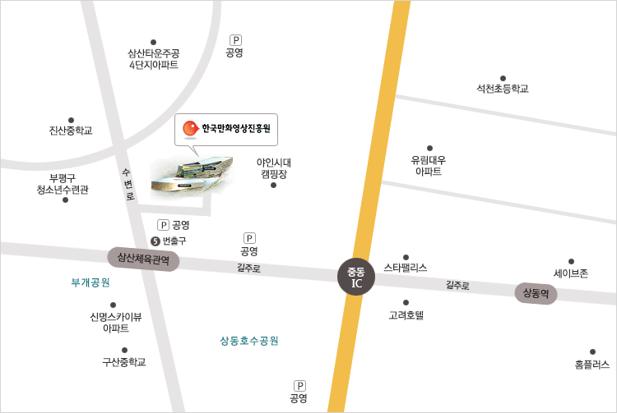 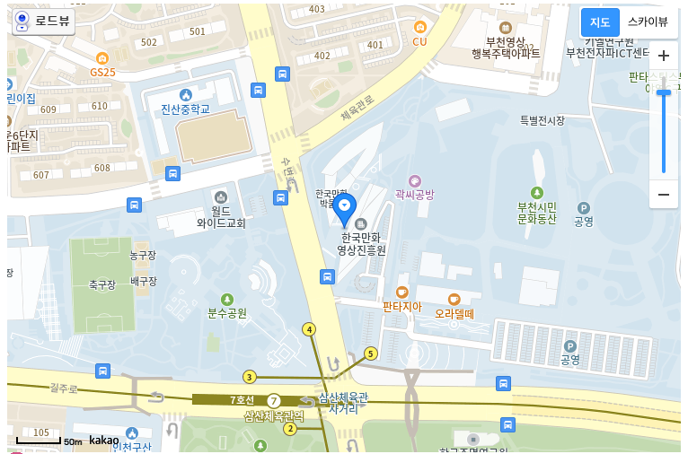

mail : innofix@nate.com

Office phone : 070-4369-8321

Mobile : 010-3712-0367

Fax : 050-4059-0367